Figure S1: Sensitivity Analysis for the P/F Ratio of the Intervention and Control Groups –use “standard difference” below
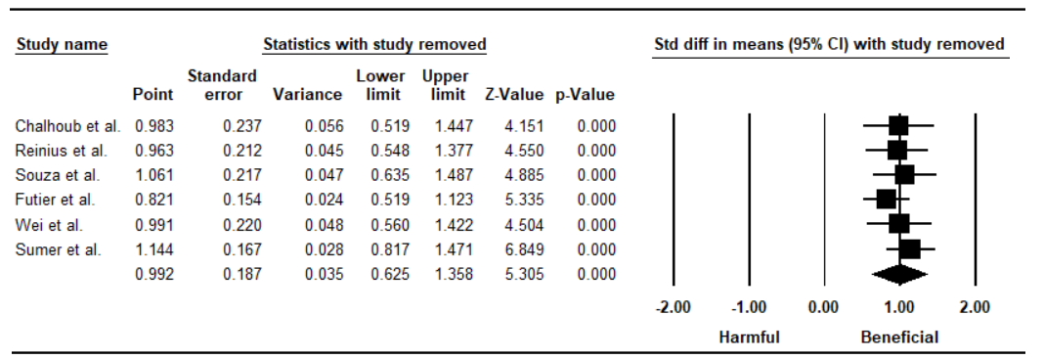

Figure S2: Funnel Plot for the P/F Ratio of the Intervention and Control Groups –use “standard difference” below
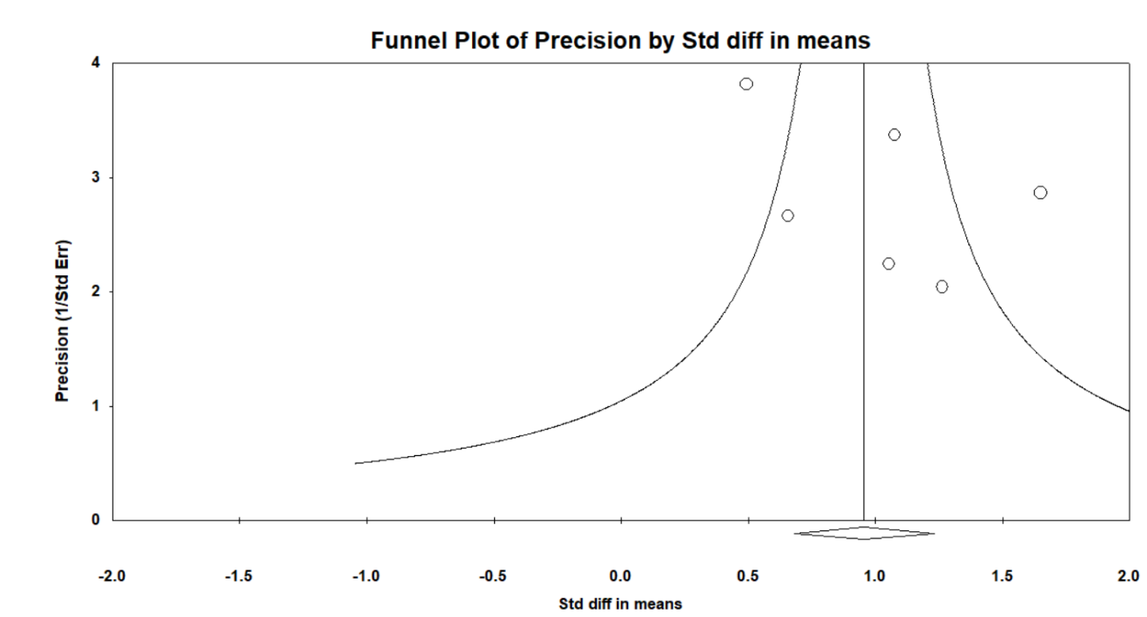
Egger’s regression test
Intercept | P-value
2.552 | 0.360

