- 台灣肺癌研究學會第2屆第2次會員大會暨學術研討會
- Faculty Form
- Please return this document by May 30, 2026, for the purpose of compiling the conference handbook. Thank you.
- 1. Faculty Information
- Prefix |  | - □ Prof. □ Dr. □ Mr. □ Mrs. □ Ms. x Other _Assistant Professor______
- Medical Title |  | - x PhD x MD. □ PT. □ Other _______
- First Name, Last name shown on passport |  | - Aaron Chia-Ken Tan
- First Name, Last Name to be printed on meeting material and name tag |  | - Aaron Tan
- Position |  | - Medical Oncologist
- Department |  | - Division of Medical Oncology
- Institution/Affiliation |  | - National Cancer Centre Singapore
- Address |  | - 30 Hospital Boulevard
- City |  | - Singapore
- Country |  | - Singapore
- E-mail |  | aaron.tan@singhealth.com.sg
- CC E-mail (if any)
- Mobile No. |  | - +65 83672592
- Dietary Preference |  | - x No Restriction │ □ Vegetarian
- 2. Portrait
- Please note:
- 1. The portrait in a .jpg or .tif format with 300 dpi is preferred.
- 2. The portrait will be used for the meeting materials
- 3. Brief Biography
- Please note:
- 1. Brief biography should be summarized in English to a maximum allowance of 200 words.
- 2. Brief biography will be shown in the meeting materials
- Dr. Tan Chia-Ken Aaron – Biography

- Dr. Aaron Tan is a Consultant Medical Oncologist at the National Cancer Centre Singapore (NCCS) and Assistant Professor at Duke-NUS Medical School, National University of Singapore.

- Dr. Tan completed his undergraduate medical training (MBBS) and Bachelor of Science (Medicine) with Honours at the University of New South Wales, Australia. Driven by a passion for oncology research, he went on to obtain a PhD in cancer drug discovery from The University of Sydney in 2011. He completed his advanced specialty training in Medical Oncology in Sydney, earning his Fellowship of the Royal Australasian College of Physicians (FRACP). Following his time in Australia, he underwent further fellowship training at NCCS, focusing on drug development, early-phase clinical trials, and lung cancer translational research.

His clinical and research interests lie in lung/thoracic oncology and cancer genomic medicine. As an active clinical investigator, Dr. Tan has been recognized with several prestigious accolades, including the National Medical Research Council (NMRC) Transition Award (2025) and multiple national and international Investigator Grants. He has published extensively in international journals on targeted therapies, immunotherapy, and molecular profiling, contributing significantly to advancing precision medicine for cancer patients.

- 4. Abstract
- Please note: Abstracts must be typed in English to a maximum allowance of 500 words.
- Topic | - ctDNA minimal residual disease (MRD) testing in early-stage NSCLC

The Asian Thoracic Oncology Research Group (ATORG) convened a 27-member expert panel to develop consensus guidance on using circulating tumour DNA (ctDNA)-based minimal residual disease (MRD) testing in early-stage resected non-small cell lung cancer (NSCLC). Using a Delphi methodology, the panel produced 23 position statements — nearly all achieving strong consensus — covering areas such as assay standardisation, clinical application, and trial design. Key findings include the need for defined analytical performance thresholds, standardised reporting and pre-analytical handling, and harmonised blood sampling timepoints across trials. While MRD assays show high specificity and positive predictive value, inconsistent sensitivity means they are not yet ready for routine use in guiding adjuvant therapy de-escalation outside of clinical trials. The recommendations also emphasise the importance of broader access, sustainable funding, and real-world data generation to support wider adoption, with future trials needing to account for the distinct biology of different driver gene subtypes.

- 台灣肺癌研究學會第2屆第2次會員大會暨學術研討會
- Faculty Form

Please kindly return this form by May 31, 2026, for the preparation of the symposium materials. Thank you.
- 1. Faculty Information
- Prefix |  | - ☑ Prof. □ Dr. □ Mr. □ Mrs. □ Ms. □ Other _______
- Medical Title |  | - ☑ PhD ☑ MD. □ PT. □ Other _______
- First Name, Last name shown on passport |  | - Hidenori Kage
- First Name, Last Name to be printed on meeting material and name tag |  | - Hidenori Kage
- Position |  | - Professor
- Department |  | - Department of Respiratory Medicine
- Institution/Affiliation |  | - The University of Tokyo
- Address |  | - 7-3-1 Hongo Bunkyo-ku
- City |  | - Tokyo
- Country |  | - Japan
- E-mail |  | kageh@g.ecc.u-tokyo.ac.jp
- CC E-mail (if any)
- Mobile No. |  | - +81-80-5988-6490
- Dietary Preference |  | - ☑ No Restriction │ □ Vegetarian
- 2. Portrait
- Please note:
- 1. The portrait in a .jpg or .tif format with 300 dpi is preferred.
- 2. The portrait will be used for the meeting materials
- 3. Brief Biography
- Please note:
- 1. Brief biography should be summarized in English to a maximum allowance of 200 words.
- 2. Brief biography will be shown in the meeting materials

Hidenori Kage is the Professor and Chair of Department of Respiratory Medicine at The University of Tokyo. After graduating from The University of Tokyo in 2000 with an M.D. degree, he completed his four years of residency and fellowship in pulmonary medicine. He then entered the PhD program at The University of Tokyo and earned his degree in 2008. He was a postdoc at the University of Southern California from 2011 to 2014. He became Professor and Chair of Department of Respiratory Medicine at The University of Tokyo in 2023. His main research interests are cancer genomic medicine and basic lung cancer research with over 130 peer-reviewed publications. He was involved in the development and approval of GenMineTOP, a comprehensive genomic profiling test with dual DNA and RNA panels. He continues to emphasize the importance of recognizing lung cancer with driver oncogene alterations and the pitfalls leading to false negative findings to appropriately treat these patients with targeted therapy.
- 4. Abstract
- Please note: Abstracts must be typed in English to a maximum allowance of 500 words.
- Topic | - Molecular diagnostics in non-small cell lung cancer

Molecular targeted therapy is a cornerstone of the treatment of advanced non-small cell lung cancer. Clinicians specializing in lung cancer around the world send biopsy and resected samples to laboratories to determine whether they harbor driver oncogene alterations such as EGFR mutations and ALK fusions, hoping to provide patients with guideline-recommended molecular targeted therapy. As the number of approved inhibitors has increased, so has the need to test multiple genes simultaneously. Use of multigene testing can preserve samples and shorten turnaround time compared with multiple single gene testing and is considered standard of care. Recently, many countries have approved comprehensive genomic profiling tests, which provide clinicians with information on hundreds of genes and give patients opportunities for novel treatments. However, we have demonstrated that genomic testing often yields falsely negative results, which can lead to patients being deprived of molecular targeted therapy and longer survival. To avoid this, clinicians must be aware of the characteristics of each test method and try to send biopsy samples that are suitable for the test method. In addition, if clinicians should consider retesting if all the genes that were tested come back negative for alterations. Finally, molecular diagnostics is not only about identifying gene alterations and matching them to molecular targeted therapy. I will conclude by explaining how they may soon transform cancer diagnosis and treatment.

- 台灣肺癌研究學會第2屆第2次會員大會暨學術研討會
- Faculty Form

Please kindly return this form by May 31, 2026, for the preparation of the symposium materials. Thank you.
- 1. Faculty Information
- Prefix |  | - Prof. □ Dr. □ Mr. □ Mrs. □ Ms. □ Other _______
- Medical Title |  | - PhD MD. □ PT. □ Other _______
- First Name, Last name shown on passport |  | - CHAO-CHI HO
- First Name, Last Name to be printed on meeting material and name tag |  | - CHAO-CHI HO
- Position |  | - Professor
- Department |  | - Internal Medicine
- Institution/Affiliation |  | - National Taiwan University Hospitall
- Address |  | - No. 7 Chung-Shan South Road
- City |  | - Taipei
- Country |  | - Taiwan
- E-mail |  | ccho1203@ntu.edu.tw
- CC E-mail (if any)
- Mobile No. |  | - 0972651317
- Dietary Preference |  | - No Restriction │ □ Vegetarian
- 2. Portrait
- 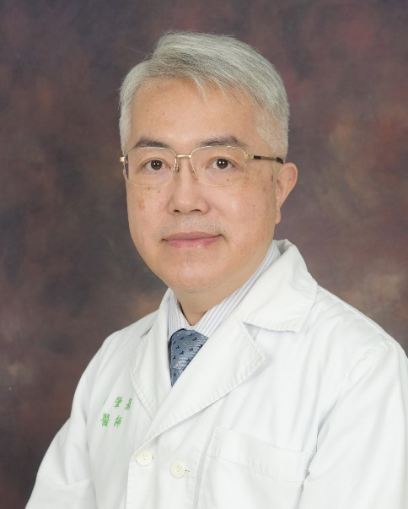
- 3. Brief Biography
Chao-Chi Ho, MD, PhD, is a Professor of Internal Medicine at the National Taiwan University (NTU) College of Medicine. Dr. Ho earned both his MD and his PhD from the Graduate Institute of Pathology at the NTU College of Medicine.
As a dedicated pulmonologist, Dr. Ho served as an ICU attending physician for nine years before focusing his career on the diagnosis and treatment of lung cancer. His primary research interests include the application of endobronchial ultrasound (EBUS) in lung cancer diagnosis, resistance mechanisms to Epidermal Growth Factor Receptor Tyrosine Kinase Inhibitors (EGFR-TKIs), and the management of EGFR-mutant lung cancer patients, including EGFR-TKI off-target effects.
Dr. Ho leads the bronchoscopy and endobronchial ultrasound teams for lung cancer diagnosis. Additionally, he serves as a co-investigator for lung cancer clinical trials led by Professor James Chih-Hsin Yang.

- 4. Abstract
- Please note: Abstracts must be typed in English to a maximum allowance of 500 words.
- Topic | - 重新檢視非吸菸族群之肺癌篩檢 ( Re-evaluating Lung Cancer Screening  - in Never-Smokers)

The current global paradigm for lung cancer screening, heavily influenced by Western trials like the National Lung Screening Trial (NLST) and the NELSON trial, relies almost exclusively on heavy smoking history as the primary risk factor for eligibility. However, this established Western framework is fundamentally inapplicable to Taiwan, where the epidemiological landscape of lung cancer is starkly different. In Taiwan, lung cancer is the leading cause of oncological mortality, yet the majority of cases occur in individuals who have never smoked. Specifically, never-smokers account for over 50% of all lung cancer cases nationwide and a staggering 90% of female patients. Historically, nearly 60% of these never-smoking patients presented with advanced stage IV disease at clinical diagnosis, highlighting a critical failure in traditional screening criteria that ignore non-smoking risks. Together, the two seminal studies on Taiwan’s experience—the retrospective national registry analysis and the prospective TALENT trial—provide definitive evidence on how to address this public health challenge. They demonstrate that introducing low-dose computed tomography (LDCT) to a never-smoking population triggers a massive, favorable stage-shift. The national registry data revealed an exponential increase in the detection of early-stage lung adenocarcinoma (LUAD) alongside a significant decline in advanced-stage incidence-based mortality (ASIBM), proving that early intervention saves lives. Crucially, TALENT identified a family history of lung cancer (LCFH) as the most powerful risk factor, demonstrating that the prevalence of invasive cancer escalates significantly with the number of affected first-degree relatives. These findings solidify the rationale for why Taiwan must shift its clinical focus entirely toward risk-stratified screening for never-smokers. Relying on smoking history leaves the vast majority of Taiwan’s at-risk population invisible to early detection, condemning them to late-stage diagnoses with poor prognoses. However, the studies also warn of "detection inflation" and potential overdiagnosis if screening is completely unrestricted, as national advanced-stage incidence remained stable in certain demographics despite surging LDCT volumes. Therefore, Taiwan’s explicit focus on never-smokers is not just justified, but medically urgent; it allows the healthcare system to abandon inefficient Western criteria and instead deploy an organized, risk-targeted national program that uses age, sex, and familial history to maximize early therapeutic intervention while mitigating the harms of overdiagnosis.

- 台灣肺癌研究學會第2屆第2次會員大會暨學術研討會
- Faculty Form
- 請於2026年5月30日前回傳，以製作本次會議手冊，謝謝您。.
- 1. Faculty Information
- Prefix |  | - Prof.
- Medical Title |  | MD, PhD
- First Name, Last name shown on passport |  | - Lin
- First Name, Last Name to be printed on meeting material and name tag |  | - Mong-Wei
- Position |  | - Professor and Chief
- Department |  | - Division of Thoracic Surgery, Department of Surgery
- Institution/Affiliation |  | - National Taiwan University Hospital, Taiwan
- Address
- City |  | - Taipei
- Country |  | - Taiwan
- E-mail |  | mwlin@ntu.edu.tw
- CC E-mail (if any)
- Mobile No. |  | - 0972653647
- Dietary Preference |  | - No Restriction
- 2. Portrait
- 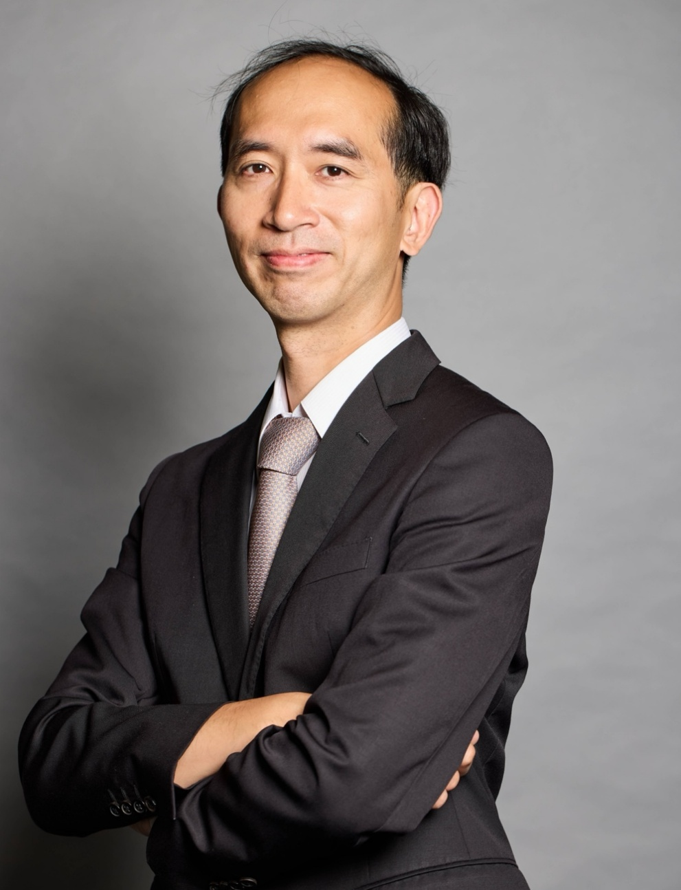
- 3. Brief Biography
- Please note:
- 1. Brief biography should be summarized in English to a maximum allowance of 200 words.
- 2. Brief biography will be shown in the meeting materials
- Dr. Mong-Wei Lin is Professor of Surgery at National Taiwan University and Vice Chair of the School of Medicine. He is Chief of the Division of Thoracic Surgery at National Taiwan University Hospital (NTUH) and serves as a board member of both the Taiwan Association of Thoracic and Cardiovascular Surgery (TATCS) and the Taiwan Society of Thoracic Surgery (TSTS).

- Dr. Lin earned his medical degree from the School of Medicine, National Taiwan University, and completed residency training in general surgery and thoracic surgery at NTUH. He pursued advanced fellowship training at Massachusetts General Hospital, Harvard Medical School, in 2010, and at Keio University Hospital in Japan in 2012. He received his PhD from the Graduate Institute of Pathology at National Taiwan University in 2014. From July 2024 to July 2025, he served as Visiting Professor of Surgery at Harvard Medical School.

Dr. Lin has authored more than 140 SCI-indexed publications in leading peer-reviewed journals, including Annals of Surgery, The Journal of Thoracic and Cardiovascular Surgery, and The Annals of Thoracic Surgery. His clinical and research interests focus on minimally invasive thoracic surgery and early-stage lung cancer, particularly through the integration of pathology, radiomics, and multidisciplinary translational research. He has received numerous awards for medical research and education and is committed to advancing thoracic surgery through innovation and improved patient care.
- 4. Abstract
- Please note: Abstracts must be typed in English to a maximum allowance of 500 words.
- Topic | - 早期肺癌治療新進展  - Recent Advances in Early-Stage Lung Cancer Treatment

The management of early-stage lung cancer has evolved rapidly with advances in surgical techniques, imaging, and perioperative technology. Minimally invasive approaches, particularly robotic-assisted thoracic surgery, have improved surgical precision, lymph node dissection, and postoperative recovery. At the same time, sublobar resection has gained increasing importance for selected patients with small peripheral lung cancers, supported by emerging evidence on oncologic safety and lung function preservation. New technologies, including advanced imaging, three-dimensional reconstruction, artificial intelligence, and image-guided surgery, are further refining patient selection, surgical planning, and intraoperative decision-making. This talk will highlight recent developments in the surgical treatment of early-stage lung cancer and discuss how innovation is reshaping personalized, function-preserving thoracic cancer care.

